PLEASE BE ADVISED AS FOLLOWS:

All relevant and appropriate sections of the FA-1 application must be filled out completely and accurately, or your form will be returned to you and approval will be withheld and/or denied.

Your farmland application may be returned as “incomplete” for any of the following reasons:

- All sections have not been filled out as requested, including acreage amounts, info pertaining to your farm operator, missing signature, etc. If your property is held in the name of a corporation – the document must be signed by a Corporate Officer.

- Acreage figures do not add-up and agree with the total acreage of the property (this can be either on the FA-1 form itself, or the Supplemental Farmland Assessment Worksheet). Also, acreage figures must match between the FA-1 & the Worksheet, by TOTAL and by CATEGORY.

- Supporting documentation was not provided as requested – which expressly applies to farms having less than 7 acres – and includes a descriptive narrative of the agricultural/horticultural uses, a sketch of their location and the number of acres devoted.

In the event your application is returned for being incomplete, you will have 10 days to re-submit a corrected application. Failure to re-submit the application by October 31, or if the re-submitted information is still incomplete or deficient, will likely disqualify the property from farmland assessment for the upcoming tax year.

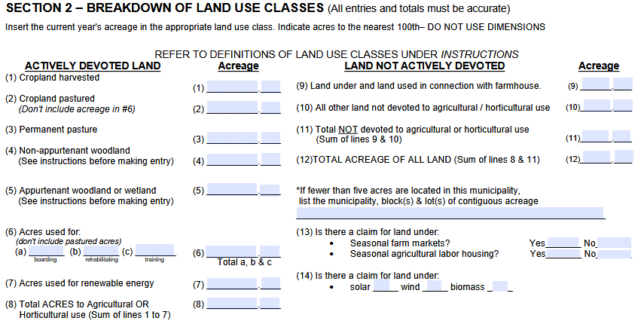
These two fields are “TOTALS” and MUST BE FILLED IN

